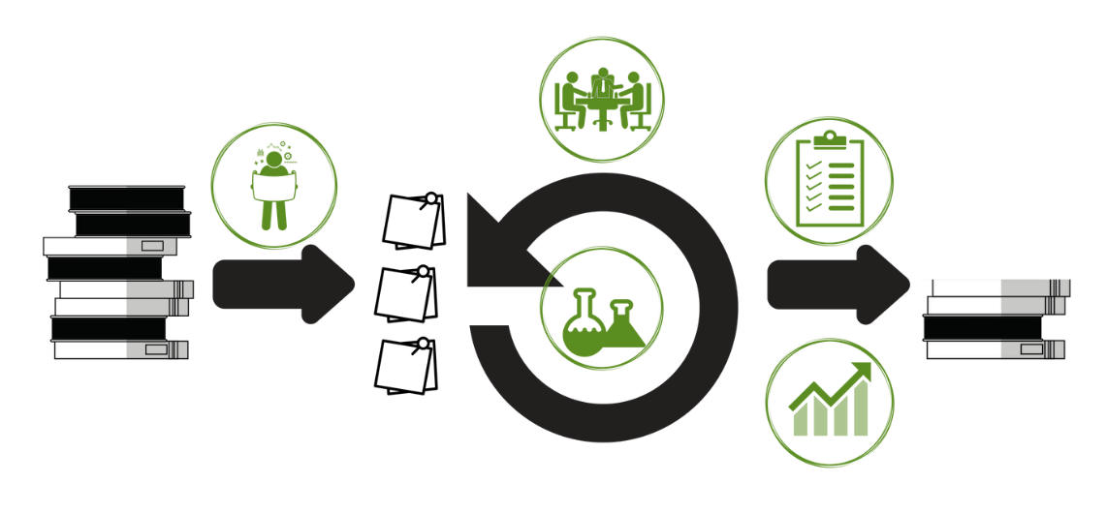

|  |  |  |  |
| --- | --- | --- | --- |
| **PLANNING EXPERIMENTS** | | | |
|  | **ACTIONS** | 1. Review your pain 2. Agree what hurts most 3. Decide how to measure progress at pain reduction 4. Define how you will measure that 5. Define some experiments to try 6. Define some improvements based results of past experiments | |
| **RUNNING EXPERIMENTS** | | | |
|  | **ACTIONS** | During **planning**, decide:   * Improvement vs Experiment * Impact Measurement | In **tracking**, note:   * Did we finish the work? * What happened to the impact measure? |
| **LEADING OWNERSHIP** | | | |
|  | **ACTIONS** | **Logistics**  Meet weekly for 7 min  Attendees: Executive, Team  Optional: Other teams under same executive  **Intent**  Team: Show current decisions  Executives: Coach on ownership | **Team Agenda**:   * What was learned since last time? * How did that insight change what we measure? * Any overall changes in technical strategy * Any resources we need, and on what timeline?   **Executive Agenda:**   * Ask what informed any specific decision * Note successful ownership moments |
| **ASSESSING OWNERSHIP** | | | |
|  | **ACTIONS** | * Which teams need my help? * Which teams should be left alone?     Score teams on their ability to prioritise, handle the unknown, learn & execute, and decide well.  *See Team Assessment Rubric for specific criteria within these categories.* | |
| **SHOWING IMPROVEMENT** | | | |
|  | **ACTIONS** | Add to the demo agenda the following items:   * Target measure * Experiments run * Results * Any strategy shifts (measure or experiments) for next week. | |